Statistical Project Objective

In the dataset linked below, some physical and performance data from a random sample of 289 weightlifters have been collected. The variables recorded for each subject are listed below.

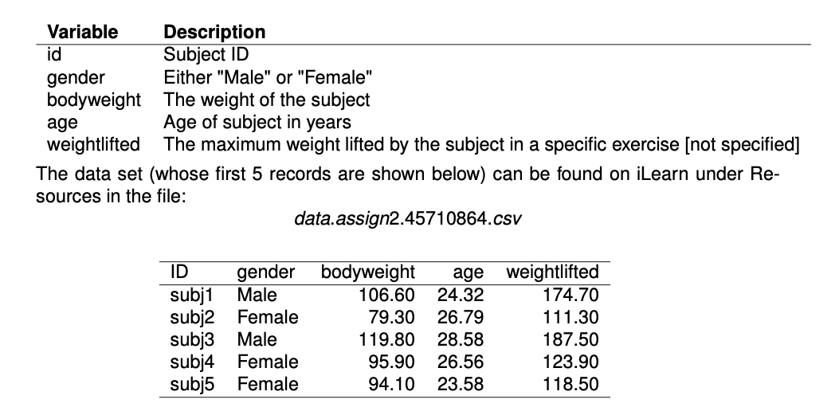

Import the data in a Minitab worksheet following the instructions below:

1. (a)  Choose File > Open Worksheet.
2. (b)  If you are using a PC, select the correct file type from the list that is located above the Open button.
3. (c)  Browse to the csv file and select it.
4. (d)  Click Open.

Check that the imported data are the same as in the table above. *Please note, the data have been generated and are in no way related to any real data set*.

The goal of this project is to write a **statistical report** which addresses the following research questions:

(a)  Is there any difference in the average age of male and female weightlifters?

(b)  What is the relation between the body weight of weightlifters and the maximum weight they can lift?

In the first question you have to check if the distribution of age has the same mean for males and females. In order to do this, you have to check the assumptions and in particular that the two samples could come from normal distributions with equal variances.  
In the second question we want to study the relation, if any, between the body weight of weightlifters and the maximum weight they can lift. In this case you have to take care of the role of the gender: can you study males and females together, or do you have to split the data set and make two regressions? Checking the assumptions will often, but not always, help you with the latter point. The results of all the possible regressions you can run will definitely answer this question.

Finally, your job is to write a statistical report. In addition to the correctness of the analyses, we will also evaluate the presentation: is the report well written, are the numerical and graphical summaries clear, are all the parts exhaustive, is the discussion/conclusion section a logical consequence of the results obtained?   
Please use Minitab (and only Minitab) to perform the analyses.